Explainable AI: Genetic Fuzzy Hand Gesture Classifier

Heath Palmer1 [0000-0002-5358-8026] and Dr. Kelly Cohen2 [0000-0002-8655-1465]

1, 2 Department of Aerospace Engineering, University of Cincinnati, Cincinnati OH 45219, USA

[palmerha@mail.uc.edu](mailto:palmerha@mail.uc.edu)

cohenky@ucmail.uc.edu

**Abstract.** Performing hand gestures is a form of nonverbal communication that occurs every day all over the world. The act of opening a door requires the hand to clench in a fist around the handle. Some may motion an individual to stop in place by flexing their hand upward with their palm facing away from the performer. Many individuals are used to performing hand gestures like these without much thought, but not everyone is this fortunate. Individuals who have lost their hand for one reason or the other are limited in their nonverbal communication capabilities. To address this, medical professionals develop controllable prosthetics driven by trained models to perform hand gestures and restore biological accurate movement. This paper aims to develop a genetic fuzzy classifier that uses myoelectric signals acquired by electromyographic sensors to characterize certain movements of an individual’s hand. The eight sensor readings are preprocessed before becoming inputs to the genetic fuzzy system. The output from the system is a single hand gesture. The genetic fuzzy classifier displays an accuracy of 67.25% using the training dataset and 69.04% using the testing set while classifying 3 hand gestures.

**Keywords:** fuzzy logic, genetic fuzzy system (GFS), fuzzy tree, controllable prosthetic, electromyography (EMG)

1. Introduction

A hand gesture is a form of nonverbal communication where the hand action communicates a message. Hand gestures are performed every day, sometimes without much thought. The muscles located in the upper arm, forearm, and hand are used to make the hand gestures. Each muscle may flex or relax depending on the gesture. ​ These muscles generate electromyogram signals when they contract, and a joint is flexed or extended. Electromyography (EMG) devices mounted on the surface of a user's forearm may be used to read the myographic signals. One EMG device that does this is the MYO armband. The armband is equipped with eight sensors equally spaced around the band that acquire myographic signals [1]. ​

Using EMG signals, developers and medical professionals attempt to refine controllable prosthetics and restore biological accurate movement to over 10,000 individuals with a lost hand [2, 3]. Before one can control the prosthetic, a model is required to be trained on the EMG signals and make predictions as to which gesture the user is trying to make. It is important that this classification model is accurate and explainable. This goal stems from a concern of user trust in the technology that is intimately integrated into their daily life. If the model wrongly predicts a gesture, the user may lose trust in the prosthetic, feel as though they do not have control over their body and feel alienated from those around them [4].

The current state of the art includes the use of artificial neural networks (ANN) and linear discriminant analysis (LDA) for their classifiers. These methods have shown to be accurate, but not very explainable. A genetic fuzzy system (GFS) is one option that can be as accurate or very close to an ANN or LDA while improving on the explainability of the system. This possibility makes it a good option for a medical application like this one. Including both a high accuracy and explainability is important for technology that has a high space co-occupation with the user so trust may be built in the intimate interaction the human has with the prosthetic.

In this paper, we discuss a GFS model that is trained using an aggregate fuzzy tree method for classifying hand gestures. The data for training the GFS is obtained from a MYO armband consisting of eight EMG sensors used to measure muscle activity while a gesture is performed. The data is published on UC Irvine’s Machine Learning Database by Lobov, Sergey, et al.

1. Literature Review

Prosthetics date back to 950 B.C.E. with a prosthetic toe and continue to impact individuals with amputated limbs all over the world. In the US, there are 41,000 registered people with an amputated hand or arm [5]. In the recent decades, there have been developments with controllable prosthetics where the user has refined control over their prosthetic compared to passive prosthetics. The controllable prosthetics use arm muscle data to perform the desired gesture for the user. For this to happen, a classification model needs trained an implemented.

There are a variety of hand gesture classification models using data from electromyographic data. Lobov, Sergey, et al. developed two hand gesture classification models using artificial neural networks (ANN) and linear discriminant analysis (LDA). Participants in their study created four hand gestures to play a modified version of Pacman. The muscle signals were recorded using a MYO EMG and used to calculate the root-mean squared values over 200 millisecond windows of time before being passed through their classification models. These classifiers exhibited F-scores between 0.88 and 0.95 [1]. Balbinot and Favieiro developed a GFS to classify their dataset which included 7 gestures with an accuracy of 86%. Their system included neuro fuzzy using adaptive neuro-fuzzy inference system (ANFIS) [6].

1. Hand Gesture Data Set

The current dataset was compiled by Lobov, Sergey, et al. during a ten-day trial where participants were asked to perform six hand gestures during a period of 3 seconds at a time. Each participant performed each gesture for a total of 6 seconds. While performing those gestures, a MYO armband was placed in the participant’s forearm and recorded myographic signals at 1,000 Hz.

From the six gestures, three were focused on during the training of the genetic fuzzy system. These three gestures include a hand clenched in a fist, flexing downward, or flexing upward. The hand at rest, radial deviation, ulnar deviation gestures were not included as gestures during classification and related data was removed. An ulnar deviation is a hand condition that occurs when the knuckle bones become swollen and cause the fingers to bend abnormally. Removing these gestures was a decision made to reduce complexity in the system.

The raw EMG data related to the hand gestures were preprocessed by calculating the root-mean-squared values over 200 millisecond windows. This calculation was done using MATLAB’s RMS function described in (1). In this function, the square of all numbers in the 200-millisecond window is calculated first. Then, the arithmetic mean of those squares is executed. Finally, the square root of the result is conducted.

(1)

$$x_{RMS}= \sqrt{\frac{1}{N}\sum_{n=1}^{N}{{\left|x_{n}\right|}^{2}}}$$

1. Methodology

A genetic fuzzy system was designed to classify hand gestures from processed muscle signal information listed in the dataset made available on UC Irvine’s Machine Learning Database. There was a total of eight inputs to the system. These inputs were RMS calculations performed over 200 millisecond windows of the raw muscle sensor data. There was a total of 4 seconds worth of data per gesture. The data was split into 50% training data and 50% testing data. These inputs were paired together based on the muscles being measured in the participant’s arm. The four muscles of interest included the *flexor carpi radialis* (FR), *flexor carpi ulnaris* (FU), *extensor carpi radialis longus* (ER), and *extensor carpi ulnaris* (EU) [1]. The eight sensors were paired as follows: sensor 5 and 6, sensor 2 and 8, sensor 3 and 4, sensor 1 and 7 accordingly. The data

The GFS was a three-layer aggregate Fuzzy Tree structure that included seven fuzzy inference systems (FIS) in Fig. 1. Each FIS was a Mamdani inference system with two inputs and one output. The inputs to each FIS on layer one was the RMS values from the sensor pairs per muscle. The output from FIS 1-4 were hand gesture predictions and used as inputs to FIS 5 and 6. FIS 5 and 6 each output a hand gesture which was used as and input to FIS 7. The final FIS output the final estimated hand gesture.

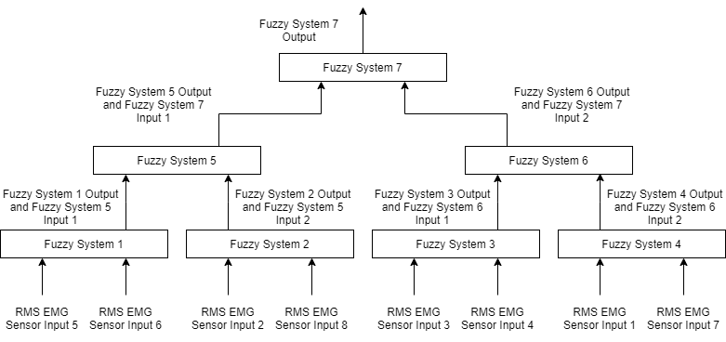

**Fig. 1.** Fuzzy Tree block diagram.

There was a total of one output from the system that specified the predicted gesture the participant was performing. There were three gestures that were chosen for the model to classify. The gestures were labeled as gesture 2 (a hand clenched in a fist), gesture 3 (a hand flexing downward), or gesture 4 (a hand flexing upward).

The fuzzy tree structure was tuned using a genetic algorithm over 50,000 generations. 20 chromosomes made up each population. There was a total of 189 genes in each chromosome. This was worked out by assigning 27 genes per FIS. There were 6 genes describing the center of each input membership function and 6 genes describing the input membership function base widths. The input membership functions were shaped like isosceles triangles. There were 3 genes describing the center of each output membership function and 3 genes describing the base width of each output membership function. The output membership functions were shaped like isosceles triangles. There was a total of 9 rules per FIS. These rules were determined using the Pittsburgh method and used the following structure: IF *input 1* AND *input 2* THEN *gesture*. Additional parameters assigned to the GA system included a probability of mutation of 0.3, a rate of elitism of 0.25, and a probability of crossover of 0.95. Double crossover was selected for this system.

The center of mass method was used to defuzzify the output per FIS. Once the output from FIS 7 was defuzzified, the genetic algorithm calculated the generation fitness value using (2) where the estimated gesture was subtracted from the actual gestures performed, then the absolute value of that difference was summed up for each data point.

(2)

$$Fitness=sum\left(abs\left(actual gesture-estimated gesture\right)\right)$$

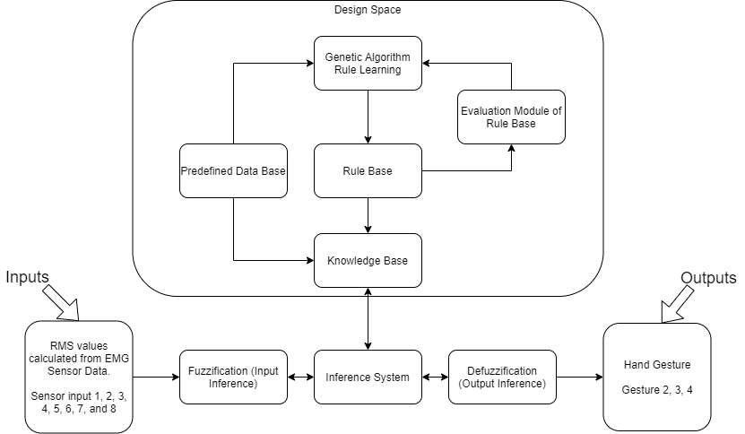

**Fig. 2.** Fine tuning process using a genetic algorithm.

Once the system was trained, the best chromosome was used to set up the classifier. This classifier was passed in the training set and testing set at separate times. The outputs from the classifier produced a decimal number between 2 and 4. These outputs needed to follow the gesture options of 2, 3 or 4 and required some post processing. The classification results were used in a greedy approach where if the decimal place was more than 0.25, then the gesture would round up to the next acceptable integer. If the decimal place was less than 0.25, then the gesture value would round down to the lower acceptable integer. This achieved a final estimated output of either gesture 2, 3 or 4 – the gestures focused on in this project.

1. Results
   1. Training

The training of the genetic fuzzy system produced a chromosome with a fitness value of 36.11 in Figure 3. This chromosome was the best after 50,000 generations but was not much better than the results in the first 5,000 generations. The best chromosome was used to define the rule base and membership functions in the fuzzy tree to classify gestures with a final output between 2 and 4 seen in Figure 4. These decimal values were later rounded up or down to determine an integer value associated with the hand gesture. That output was either gesture 2, 3 or 4 and used to create the confusion matrix in Figure 9. That confusion matric was used to calculate the performance metrics in Table 1. The classifier using the best chromosome parameters displayed a classification accuracy of 67.25%.

The input membership functions displayed great overlap for FIS 1 and FIS 7 displayed in Figures 5 and 7. The output membership functions for FIS 1 and 7 are displayed in Figures 6 and 8. Additional membership functions for each FIS may be displayed by modifying the code. The first, second, and third membership functions for both inputs and outputs are colored blue, orange, and yellow, respectively.

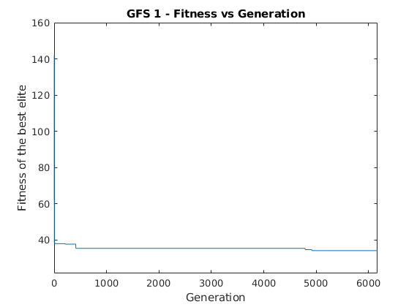

**Fig. 3.** Fitness function while training.

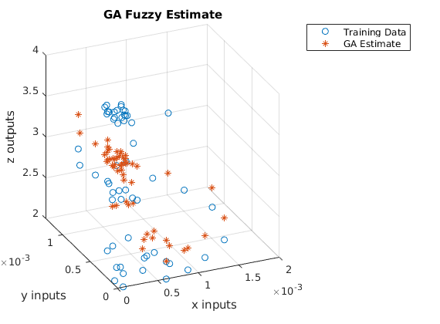

**Fig. 4.** GFS Gesture Training Estimate Scatter plot.

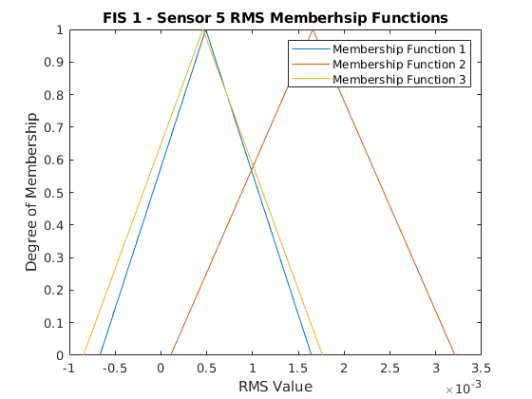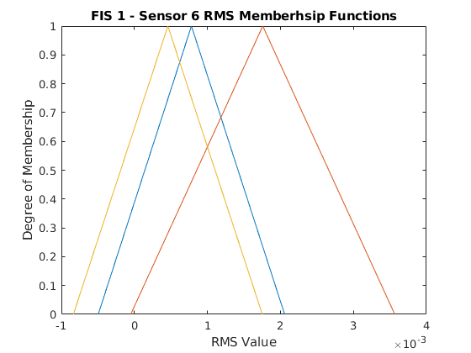

**Fig. 5.** FIS 1 Input Membership Functions. Left: RMS input 1. Right: RMS input 2.

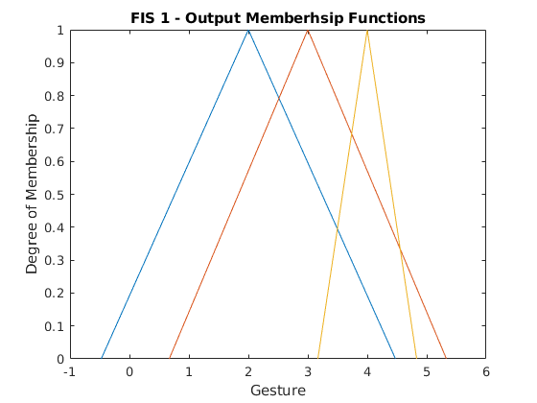

**Fig. 6.** FIS 1 Output Membership Functions.

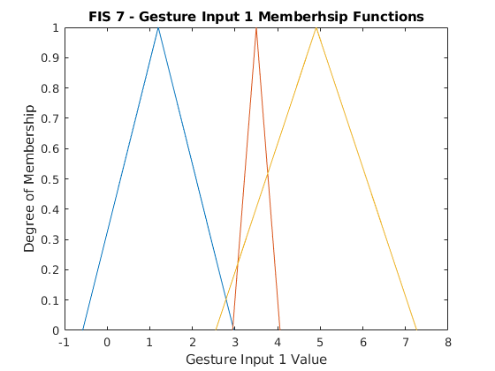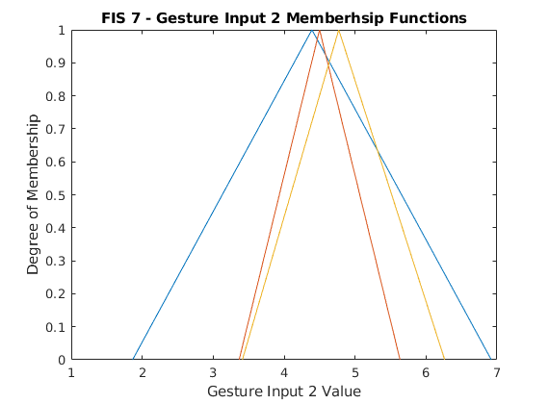

**Fig. 7.** FIS 7 Input Membership Functions. Left: Gesture Estimate Input 1. Right: Gesture Estimate Input 2.

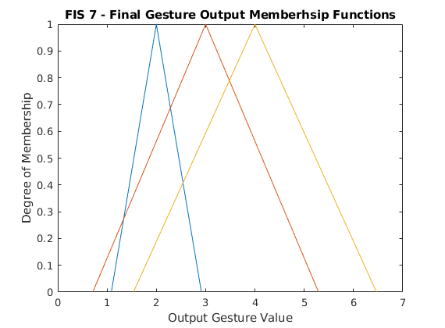

**Fig. 8.** FIS 7 Output Membership Function.

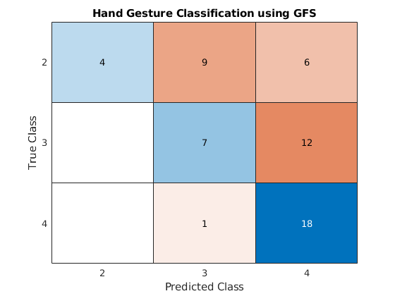

**Fig. 9.** Training Set Confusion Matrix.

**Table 1.** Training Performance Metrics.



* 1. Testing

The classifier was given a testing set of RMS values which resulted in a 69.04% accuracy in Table 2. The performance parameters were calculated based on the confusion matrix in Figure 10.

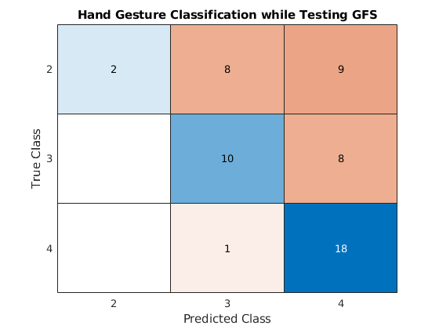

**Fig. 10.** Test Set Confusion Matrix.

**Table 2.** Test Set Performance Metrics.



* 1. Data Visualization

The RMS values calculated based on the eight EMG sensors is visualized in Figure 11. This was conducted late in the development process. There does not appear to be any strong correlation between the inputs which makes it difficult to continue with an aggregate fuzzy tree structure. A cascading fuzzy tree model is meant to handle uncorrelated data and may be explored in the future.

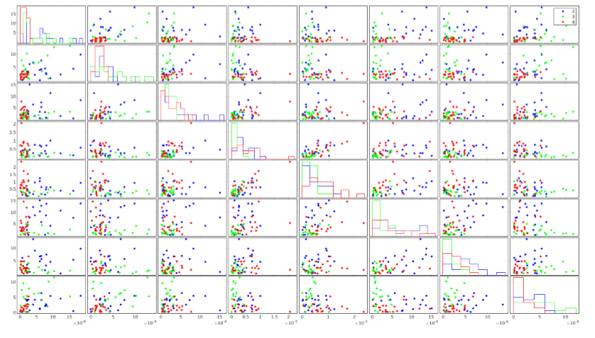

**Fig. 11.** Scatter plot matrix of the eight sensor readings as RMS values and their assigned gesture. Blue data points represent gesture 2. Green data points represent gesture 3. Red data points represent gesture 4.

1. Conclusion and Future Work

In this paper, I present the development and performance of a GFS for classifying hand gestures performed by individuals wearing a MYO EMG armband. The GFS was implemented seven FIS in an aggregate fuzzy tree structure tuned by a genetic algorithm. The GFS was evaluated using precision, recall, and F1-score performance metrics. The GFS could not be compared to results produced by Lobov, Sergey, et al. since a different dataset was used in their classifiers. The sensor data was determined to be more uncorrelated than initially anticipated.

There are a few next steps I would like to take with this project soon. First, I would like to compare the aggregate Fuzzy Tree structure with either an incremental or cascading structure. This step is necessary after determining that there is less correlation between the sensor values than previously thought. Second, a new data set shall be reviewed that includes MYO armband EMG signals and their associated hand gestures. This data set shall have been implemented with classification models using tools like ANNs and LDAs to ensure an easy comparison with my GFS. Finally, learning of additional hand gestures shall be explored to expand the capabilities of the system.

References

1. Lobov S., Krilova N., Kastalskiy I., Kazantsev V., Makarov V.A. Latent Factors Limiting the Performance of sEMG-Interfaces. Sensors. 2018;18(4):1122. doi: 10.3390/s18041122
2. Roche, A.D., Rehbaum, H., Farina, D. et al. Prosthetic Myoelectric Control Strategies: A Clinical Perspective. Curr Surg Rep 2, 44 (2014). <https://doi.org/10.1007/s40137-013-0044-8>
3. Industrial Safety &amp; Hygiene News. “Statistics on Hand and Arm Loss.” ISHN RSS, ISHN, 28 Jan. 2014, [www.ishn.com/articles/97844-statistics-on-hand-and-arm-loss](http://www.ishn.com/articles/97844-statistics-on-hand-and-arm-loss).
4. Graczyk, E. L., Gill, A., Tyler, D. J., & Resnik, L. J. (2019). The benefits of sensation on the experience of a hand: A qualitative case series. PloS one, 14(1), e0211469.
5. Schulz S., Pylatiuk C., Bretthauer G. A New Ultralight Anthropomorphic Hand. Proceedings of IEEE International Conference on Robotics and Automation; Saint Paul, MN, USA. 14–18 May 2001; pp. 2437–2441. [[Google Scholar](https://scholar.google.com/scholar?q=Schulz+S.+Pylatiuk+C.+Bretthauer+G.+A+New+Ultralight+Anthropomorphic+Hand+Proceedings+of+IEEE+International+Conference+on+Robotics+and+Automation+Saint+Paul,+MN,+USA+14%E2%80%9318+May+2001+2437+2441+)]
6. Balbinot, A., & Favieiro, G. (2013). A neuro-fuzzy system for characterization of arm movements. Sensors (Basel, Switzerland), 13(2), 2613–2630. https://doi.org/10.3390/s130202613
7. Krasoulis, A., Kyranou, I., Erden, M. et al. Improved prosthetic hand control with concurrent use of myoelectric and inertial measurements. J NeuroEngineering Rehabil 14, 71 (2017). <https://doi.org/10.1186/s12984-017-0284-4>